**Experiment No.:**

**Aim :-** Instagram threads login page

**CO1:** Design and develop user interfaces for mobile apps using basic building blocks, UI components and application structure using Emulator

**Procedure**

<?xml version="1.0" encoding="utf-8"?>  
<LinearLayout xmlns:android="http://schemas.android.com/apk/res/android"  
 xmlns:tools="http://schemas.android.com/tools"  
 android:layout_width="fill_parent"  
 android:layout_height="fill_parent"  
 android:gravity="center"  
  
 android:background="@drawable/bg11"  
 android:padding="20dp"  
 android:orientation="vertical"  
 tools:context=".MainActivity">  
  
 <TextView  
 android:id="@+id/textView1"  
 android:layout_width="wrap_content"  
 android:layout_height="wrap_content"  
 android:layout_gravity="center"  
 android:layout_marginTop="30dp"  
 android:text=""  
 android:textAppearance="?android:attr/textAppearanceLarge"  
 android:textColor="#FD1616"  
 android:textSize="34sp"  
 android:textStyle="bold"  
 android:typeface="sans" />  
  
 <EditText  
 android:id="@+id/etunm"  
 android:layout_width="280dp"  
 android:layout_height="50dp"  
 android:layout_marginTop="20dp"  
 android:layout_marginBottom="20dp"  
 android:background="@color/white"  
 android:backgroundTint="#C6D5D5D5"  
 android:ems="10"  
 android:gravity="center"  
 android:hint="Username,Phone Or Email"  
 android:textColor="#070707"  
 android:textColorHint="#494949">  
  
 <requestFocus />  
 </EditText>  
  
 <EditText  
 android:id="@+id/etpass"  
 android:layout_width="280dp"  
 android:layout_height="50dp"  
 android:layout_marginBottom="20dp"  
 android:background="@color/white"  
 android:backgroundTint="#C6D5D5D5"  
 android:ems="10"  
 android:gravity="center"  
 android:hint="Password"  
 android:inputType="textPassword"  
 android:textColorHint="#494949" />  
  
 <androidx.appcompat.widget.AppCompatButton  
 android:id="@+id/btnlogin"  
 android:layout_width="280dp"  
 android:layout_height="wrap_content"  
 android:layout_gravity="center"  
 android:layout_marginTop="30dp"  
 android:drawableRight="@drawable/btn"  
 android:drawablePadding="30dp"  
 android:text="Log In With Instagram"  
 android:backgroundTint="#000"  
 android:textColor="#FFFFFF" />  
</LinearLayout>

**Output Screenshot**

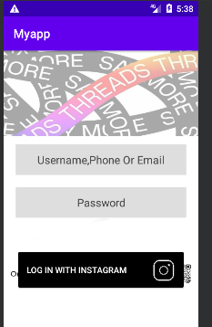

**Result**

The program was executed and the result was successfully obtained. Thus CO1 was obtained.